Task 5: To create navbar like this.

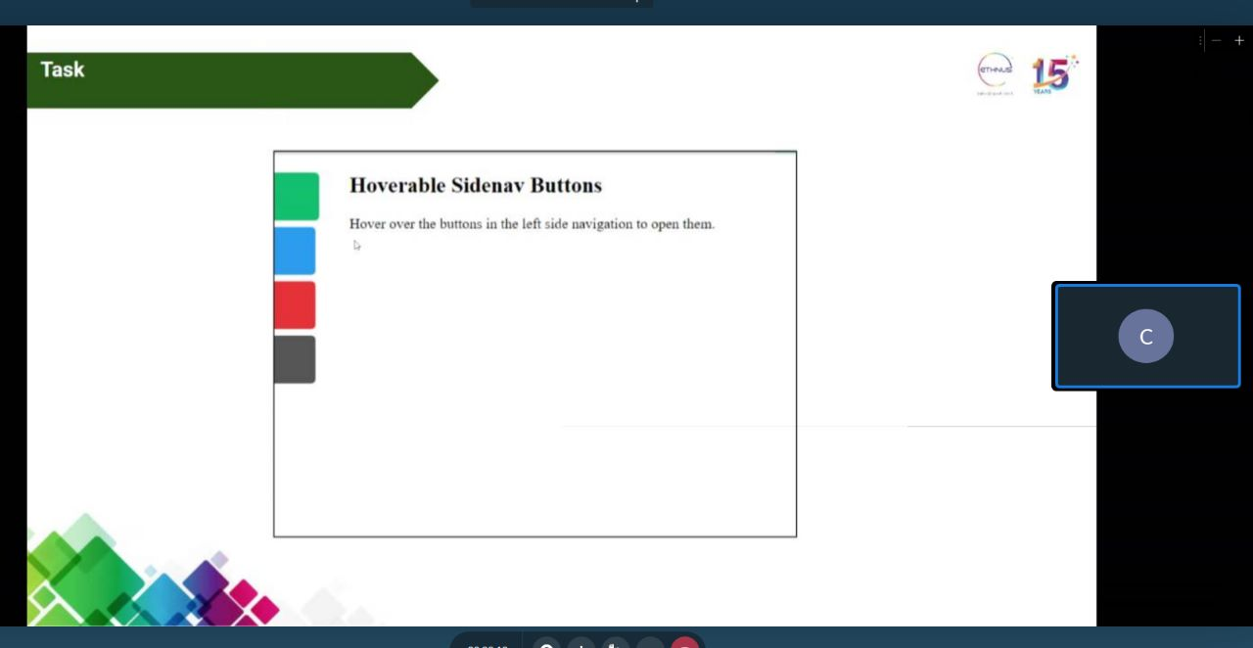

HTML code:

<html lang="en">

  <head>

    <link rel="stylesheet" href="hover.css" />

    <meta charset="UTF-8" />

    <meta http-equiv="X-UA-Compatible" content="IE=edge" />

    <meta name="viewport" content="width=device-width, initial-scale=1.0" />

    <title>Hover buttons</title>

  </head>

  <body>

    <br />Side Navbar on hower - 20BCE2096 <br /><br />

    <div class="side-buttons">

      <div class="button" style="background-color: green"></div>

      <div class="button" style="background-color: blue"></div>

      <div class="button" style="background-color: red"></div>

      <div class="button" style="background-color: grey"></div>

    </div>

  </body>

</html>

CSS code:

\* {

  box-sizing: border-box;

  margin: 10px;

}

.button {

  display: block;

  width: 100px;

  height: 50px;

  text-align: center;

  line-height: 50px;

  margin-bottom: 10px;

  color: #333333;

  cursor: pointer;

  transition:  width 0.3s, height 0.3s;

}

.button:hover {

  width: 150;

  height: 100px;

}

Output:

